Here are your Exclusive Card Designs
WHAT'S INCLUDED:
Place Card Templates - The Bride, The Groom, Reserved, Editable Name Cards or Blank Cards
Size 2 x 3.5 inch -customizable and ready to print!
PRINTING
Please follow any instructions provided with the cards.

GENERAL PRINTING GUIDELINES
1. Open the file.
2. Edit the names on the cards, or use backspace to remove the names for blank cards.
3. Click on File and select Print.
4. Select to print page 2
5. Go to Page Size tab and choose the appropriate size option
6. Go to Page Scaling and choose Fit to Printable Area option in the list (this may also be labeled as "Fit to Printer Margins").
7. Click on the OK button to print.
8. Repeat to print more names.

Please Note:
Printers are all different, and you may need to check and change settings to get the print out layout correct. Please do some practice print-outs first to make sure that the printing is all formatting correctly before you print on your card stock.

Suitable for card stock up to .039" / 1mm/ 1000 microns thick.
Please check that cards fit the holders before printing.
Always test results before printing a large quantity.

We aren't printing experts, so please do not ask us for help with printing.
We supply these designs to you free of charge and hope you find them useful, but we accept no responsibility for any printing issues that may occur.

Copyright © Pretty Display. All rights reserved.
No part of this publication may be reproduced, distributed, or transmitted in any form or by any means, including printing, photocopying, publishing or other electronic or mechanical methods, without the prior written permission of the copyright owner, except in the case of personal use by Pretty Display™ Customers.

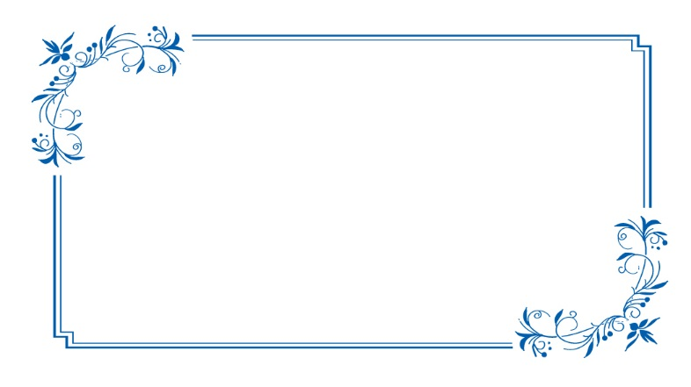  The Bride |  | The Groom
Reserved |  | Name
Name |  | Name
Name |  | Name

